Town

An abstract, interactive experience.

Lee Kempton

10520595

Git Hub Link:

<https://github.com/LKempton/StreetScene>

YouTube Playthrough:

<https://www.youtube.com/watch?v=mKY-GsjZvCc>

(Note, this playthrough shows the completion and ending of the game, however it doesn’t explore much of the environment or read many of the messages around the game world)

# Overview

## Genre

The overall genre of Town I would describe as an interactive, story focussed experience with themes of varying psychological states and feelings, which is presented through the environment.

The game takes place from a first person perspective, this I feel is the most immersive camera angle to take in a game about exploring an unknown world. The overall theme is subtle and is purely presented through environmental story telling. Town also makes use of an ominous soundtrack mixed with dark environments to convey a negative feeling to the player.

## Target Audience

Town will be a PC release, this is due to the fact the game is free and short in length, so is better suited as a short, ‘throw away’ experience on the PC platform. Small indie titles such as this are usually at home on the PC so this is the main consideration to choosing this platform.

The game will be aimed at the mature audience, this is due to explicit dark themes that are often presented through the environment. While the art style is simple, it is still dark and instils a sense of unknown and possibly dangerous entities, which I feel is something that should be reserved to a mature audience.

Finally, the game is single player and fairly short in length, so it would fit in with an audience that prefers non-rushed, more relaxed gameplay with no timers or competitive elements in place to break immersion of the player. Town should be played at the players own pace and they should take time to truly explore the environment.

## Game Story

The player in Town starts the game outside, near a boarded up well. The whole area is a sort of canyon with 4 houses and the aforementioned well, including a fair amount of foliage like trees and grass. The player has no idea how they got where they are and from reading messages in the environment get the overall goal is to open the well to ‘escape’.

The story for Town is left purposely vague as I wanted the player to come up with their own questions from environmental story messages. These message are a mixture of the player character’s thought and what appears to be ‘memories’ of people who could have lived in the houses. The messages are intended to make the player consider what their relationship to the town is and whether these people are actually different to the player at all. The fact that the keys for a cabinet are found throughout all the houses is meant to contrast the idea that each house is a family or person with the possibility that all the houses could be a single entity, whether that be the player, an unknown character or something else, which is down to interpretation from the player.

The ending sequence helps to show that the town is not a real thing and seemingly only a simulation or fake. Ending the game at the miniature town causes the main menu to come up, which is a slow panning camera of the town. This idea of a loop of the player going around and around is done as a metaphor to how a lot of the psychological themes shown through the environment often occur and repeat in people who suffer from a lot of the issues depicted.

Finally, the goals themselves are a part of the story as they are designed to make sense as a list of goals, which breaks the consistent abstract feel that the strange ‘Town in a canyon’ has. This is done so that the player can follow a lot of the things that make sense easily and these are the first thing to be understood. Overall, I want the games story to be open and not constricted to a definite ending, rather what the player can gain from exploring the environment.

## 

## Game Concept

I wanted Town to be a little bit out of the ordinary as far as my street scene goes. I first started out with a trippy, almost drug like experience but as I went along with the modelling and beginning stages of the project I shifted my ideas into different directions. Namely, I wanted to move more towards a sort of journey through the mind, but from a third person (character not camera angle) perspective. I wanted the player to be walking through an environment and for all these things to be inferred from the environment, with their causes or effects highlighted through messages.

I liked the idea that when the game ends it doesn’t really end, looping back around to the beginning or perhaps an alternative version of the world each time, which I feel allows for a fair amount of expansion of the idea should I want to at a future date. The ending with the miniature town is one of my favourite parts and I really like how it looks and think it is suitable for an ending.

There is no timer in Town and the only failure state is not finding the various items and escaping down the well. This is so the player can take their time and explore the environment without any real pressure. In addition, the world itself is within a fairly small area, this is because I wanted the player to explore but I didn’t want them to be walking for a long time outside or getting lost. The 4 houses and well provide ample play space to walk around and read messages, gaining story knowledge.

## Game Flow

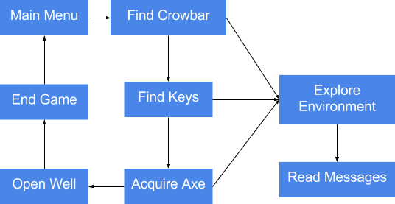

The game flow is split into two distinct paths, first there is the goals that are needed to be completed so that the player can proceed, and these are part of the main looping path on the diagram. Coming off of the three separate in game events that are part of the goals while the player is on the map, is the ‘Explore Environment’, this is optional and doesn’t lead to any additional event besides story implications and giving the player extra things to do.

# Game Structure

## Game Progression

Town has fairly basic progression mechanics. The majority of the progression comes from the fact that only a single house is open at the beginning of the game. This house is where the player can find the crowbar, which is required to open the other three houses and therefore progress.

Upon trying to open the well with the crowbar (if they try to), the player will find out that this isn’t enough to open the well and they need to find something else. This item is the axe, which can be found behind a cabinet in one of the previously locked houses. At this point the player has likely found at least one key, which means they can infer the key is for the cabinet.

The final level of progression is finding the 5 keys in order to open the cabinet and retrieve the axe, allowing the player to open the well. From entering the well the player can only explore the end chamber and then end the game when they feel they have had enough.

## Goals

The goal for the player is to find a way to open the well. They can do this by finding a series of items finalising in the fire axe which is locked in a cabinet in one of the locked houses. The player must find a crowbar to open the house doors and then 5 keys in order to open the 5 locks on the cabinet. These are spread about throughout each house so the player has to look around to try and locate them to complete the game.

## Rules

* A crowbar must be used to open locked doors,
* A fire axe must be used to remove planks from the door,
* The game plays until the player finds the way out or gives up,
* Keys must be collected to unlock access to the fire axe,
* 5 keys are needed in total to get to the axe,
* The player can jump to look behind objects or navigate the houses,
* The player can sprint to cover more distance quickly,
* The player can use the always on flashlight to look around dark environments,
* The player can end the game once entering the final chamber.

# Mechanics

## Interaction

The player can interact with certain items in the world, these include: doors, keys, axe, crowbar, planks and the axe cabinet. The player can also interact with the story messages simply be looking at them to display text. All interact-able items emit a small amount of light, meaning they can be seen inside the dark interiors of the houses even if the player is not directly shining a light on them.

All items apart from the messages are interacted with by using the ‘Interact’ (E) key while looking at them, this is prompted on screen with text. Each item has a feedback sound along with it, or some voice acting. Some items require the player to pick up another item to be able to interact with them.

## Movement

The game takes place from a first person camera perspective and controls like a standard fps type game. With WASD being used for movement, Shift being used for sprint, E being used for interact and Space being used to jump.

The camera is controlled with the mouse and also acts as a flashlight, which is useful in dark areas.

## Objects

The main objects used in the game are different for each side. The human player only uses a base set at the start of the level that can deploy and build units, and apart from that the only objects the play interacts with are troop units and other player built items. The Goblin player can interact with other goblin AI, the towers built and the goblin base.

## Combat

Town doesn’t feature any combat and all the gameplay is done directly through interacting with the environment and reading messages.

## A.I

As the player is the only character present in Town there is no AI needed. It is quite important that the player is the only character due to the idea that the character is alone and exploring a seemingly abandoned series of house that are distinctively lived in while still being unusually empty and lifeless.

## Space

The game space is consisting of two areas, one large, main area where all the houses are located, and one smaller area which is for after the player jumps down the well.

The main area is round in shape, surrounded by mountains, which is there to make the player question how they themselves even got there themselves. The four houses and well are all located around the edges, facing into the centre, leaving a larger open area in the middle between everything. Trees are punctuated in the spaces between each house and two fences are on either side of well. This is all done for aesthetic purposes and doesn’t have any real gameplay reason besides making each house roughly the same distance from each other, making for easier exploration.

The final area consists of a small chute type drop and then an open square room, containing only a table, with a miniature version of the town the player was just in. The previously carried flashlight is the only thing that lights up the room until the player gets close enough to the table to trigger a second light. The area behind and above where the player fell from is completely black, prompting forward movement.

# Menu System

## Menu Diagrams

**Main Menu Scene**

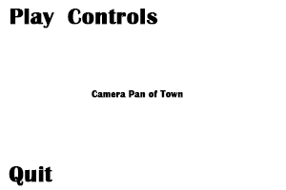

The main menu is simple in design, not even containing the games title, but rather showing it by the background, which will be a camera panning around the centre of the world, from just above house height. The controls button brings down a small tab showing the inputs for the game and the quit button exits the application.

The Play button takes the player into the game scene, which is the same town the camera has been rotating around during the menu. If the player watches the menu camera long enough they can get a brief idea that only one house is open, giving them a lead in the game.

**In-Game UI**



The in game UI is very basic, with only a small reticule in the centre of the screen to aid the player with interacting with the environment. There is addition text for when you hover over intractable which is show slightly below the reticule.

I wanted the UI to be basic as I didn’t want inventory systems and counters to distract the player.

* 1. Menu Flow Diagram

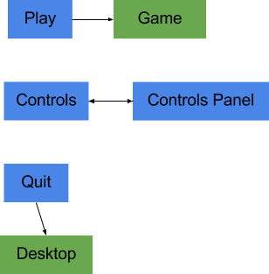The menu for this game is very basic and non-customisable, this is because there isn’t much need for customisation due to the fact the game runs well on near enough everything.

# 

# Level Design

## 

## Level Diagrams



There is only one level in this game as shown above, it is based in one room only - with the outside part being used for the human player to direct their troops. The human are trying to fight through to the orcs, who is essentially a boss.

# Artistic Direction

## Mood Boards

**Game World**

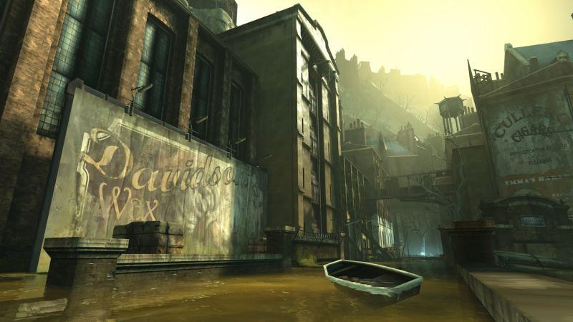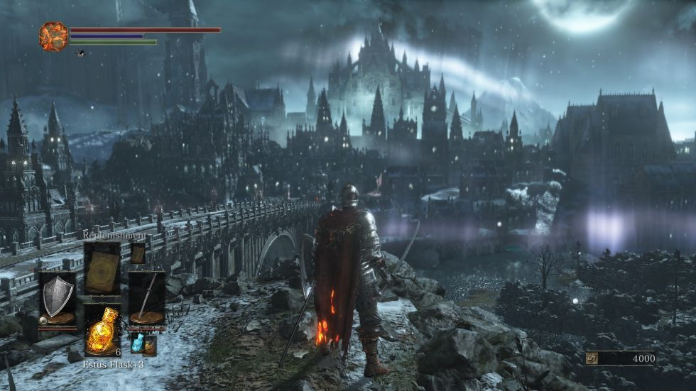

The game world has taken inspiration from games such as Dishonoured and Dark Souls, a dark fantasy world with a heavily run down and oppressed theme. Buildings have a gothic style and the whole world has a very dark pallet, using minimalist colours.

**Towers**

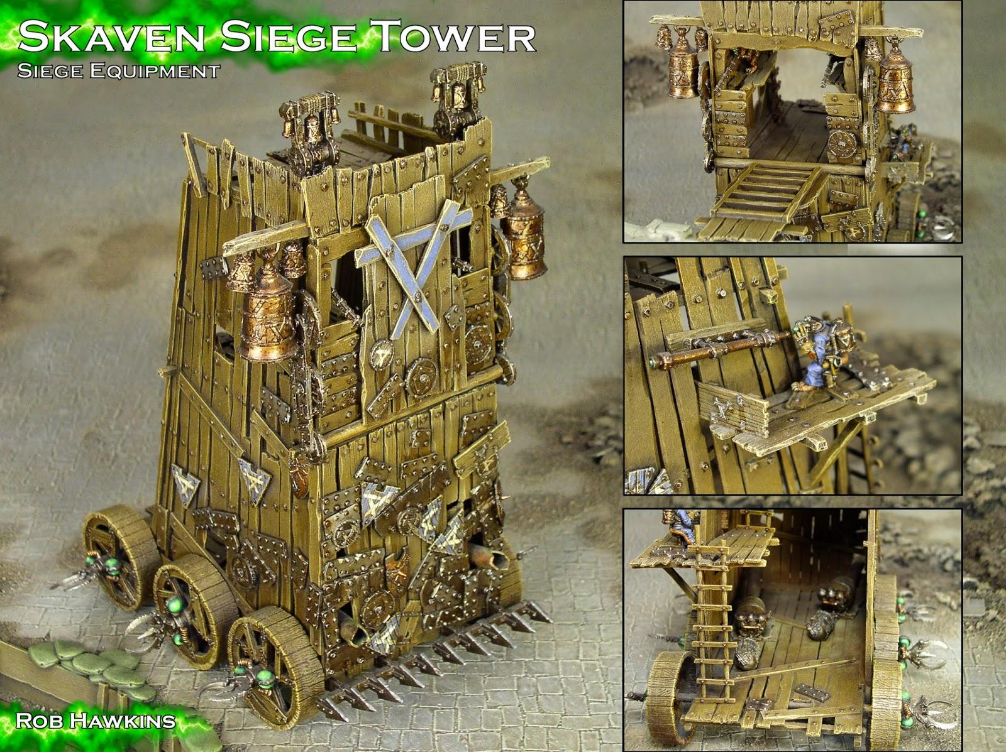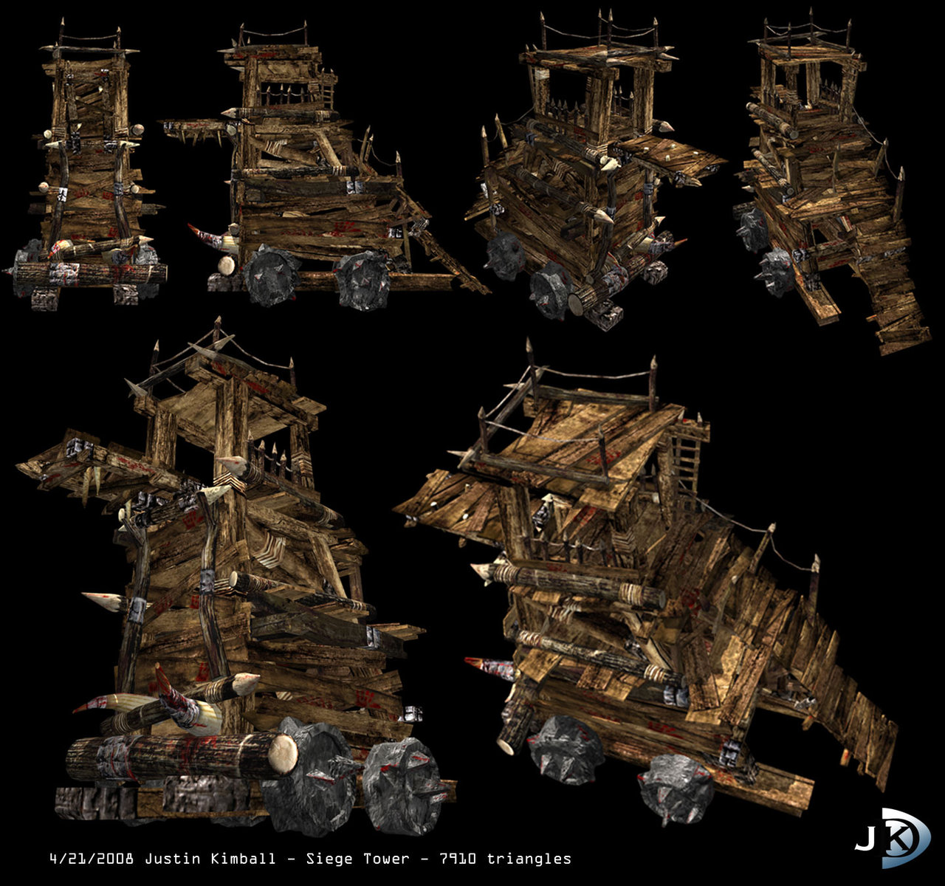

The towers that are built by the goblins have a very run down theme, built with scrap wood and metal found in the environment. The look very rickety and hazardous, which fits into the gameplay as they constantly need repair and can sometimes damage the goblin builders.

**Humans**

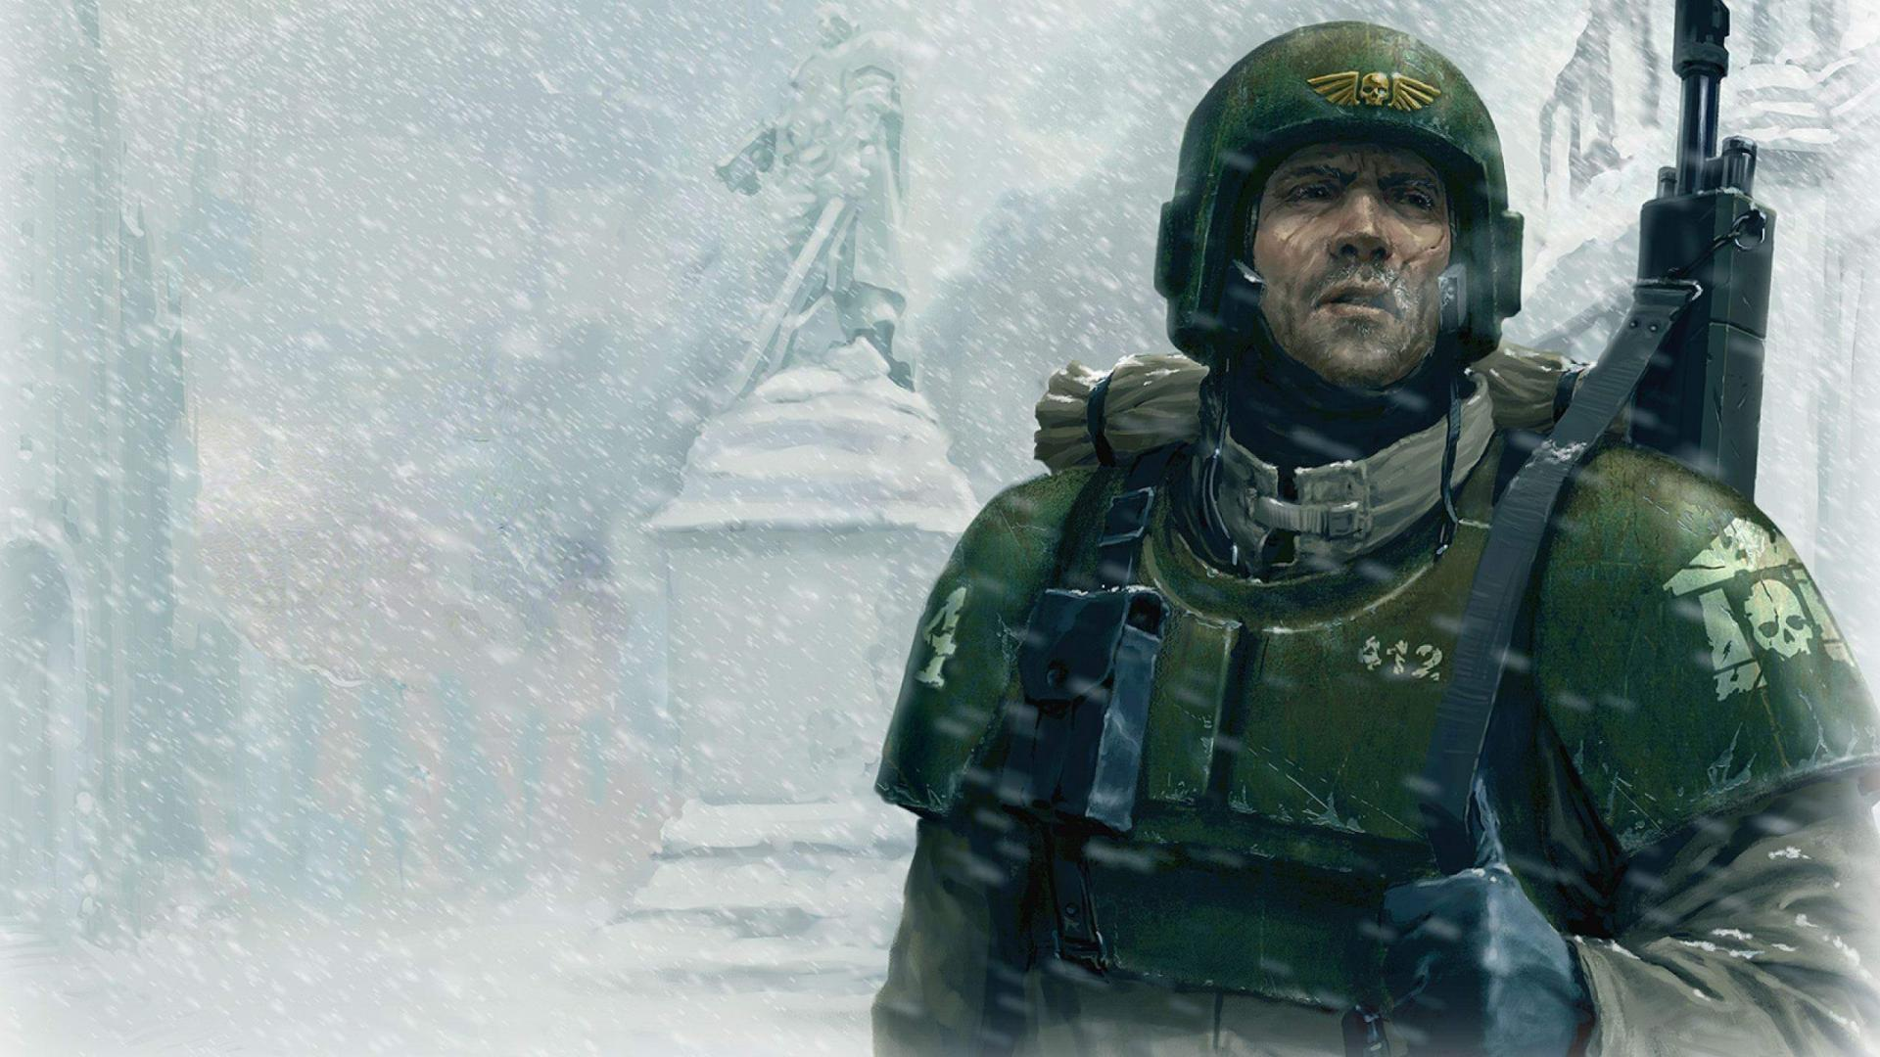 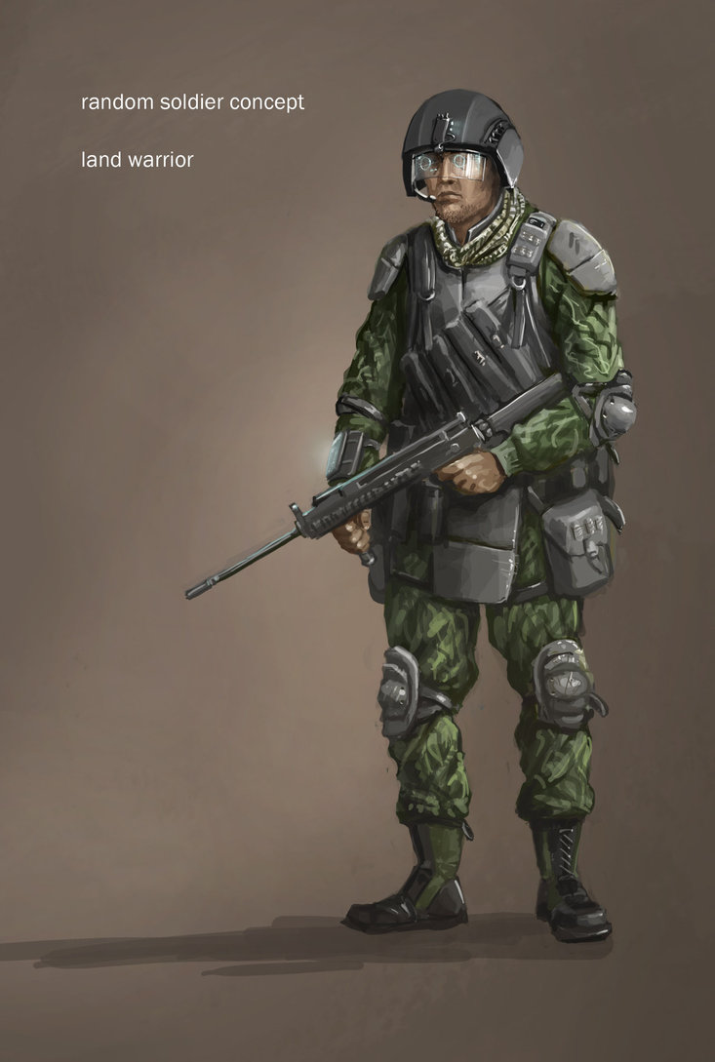

For the human side, they are loosely modelled after the imperial guard troops from Warhammer 40k. Uniform armour built around a base of thick fabric with big metal plates covering the main areas of the body (head, chest, shoulders etc.)

**Goblins**

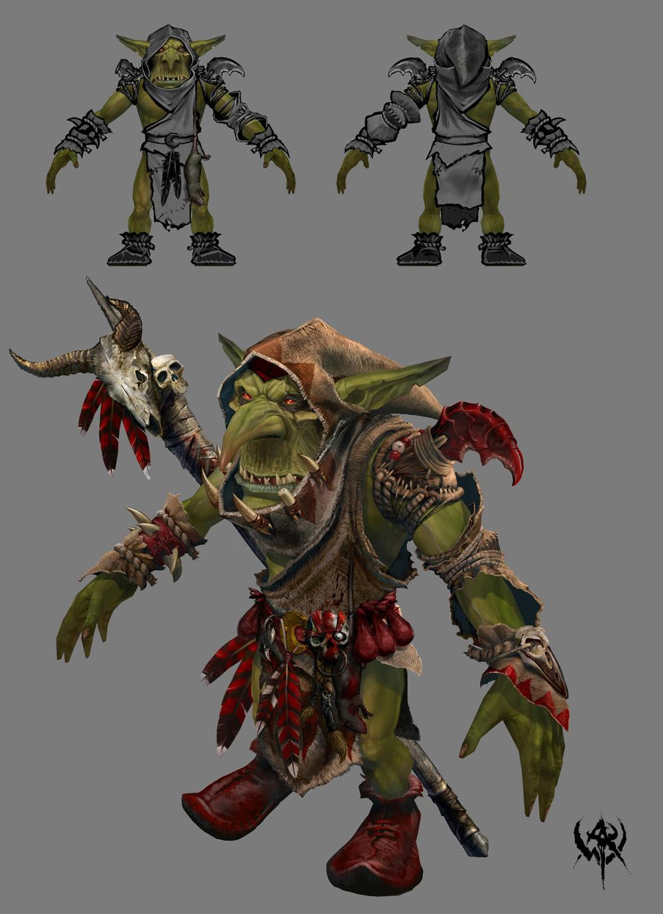 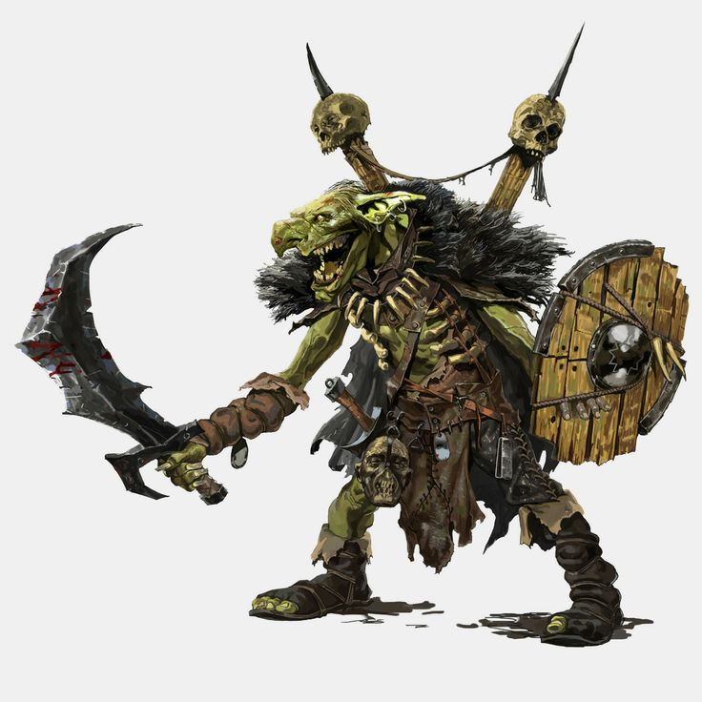

As for the Goblins, their style is based around a classic goblin look, thick green skin and armour made of mismatched fabrics and scrap metal they find in the environment.

**Orcs**

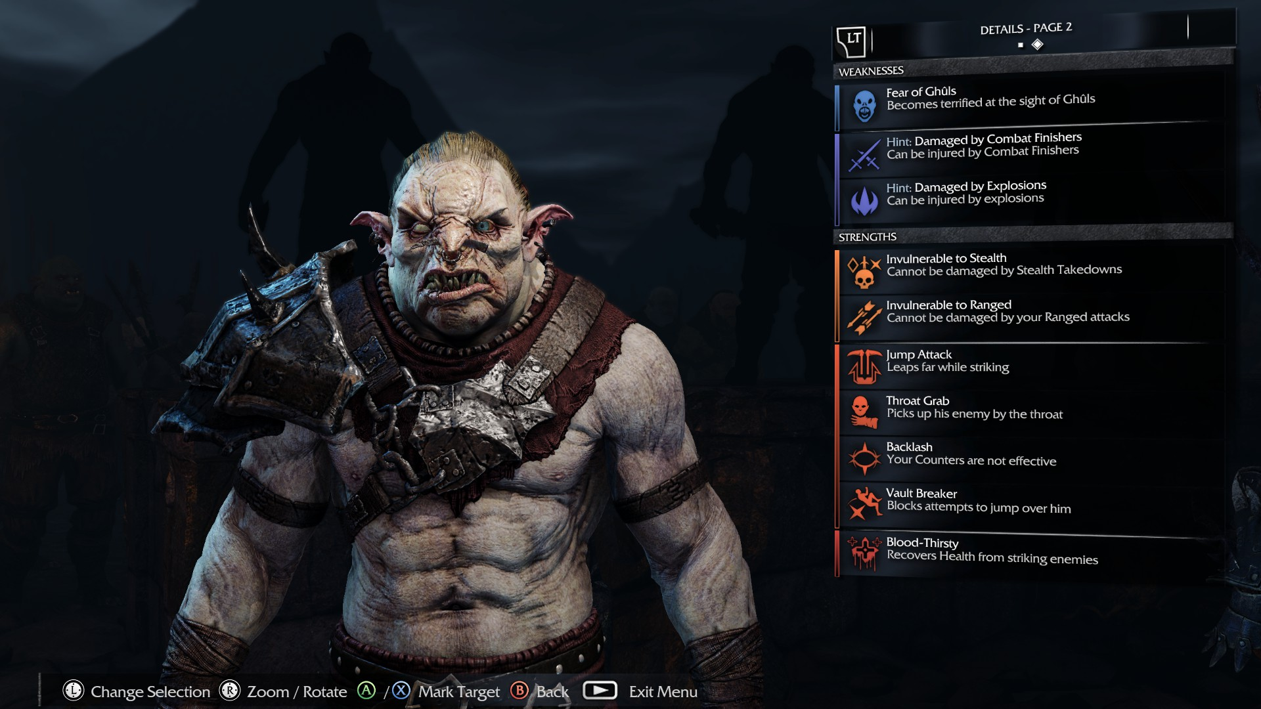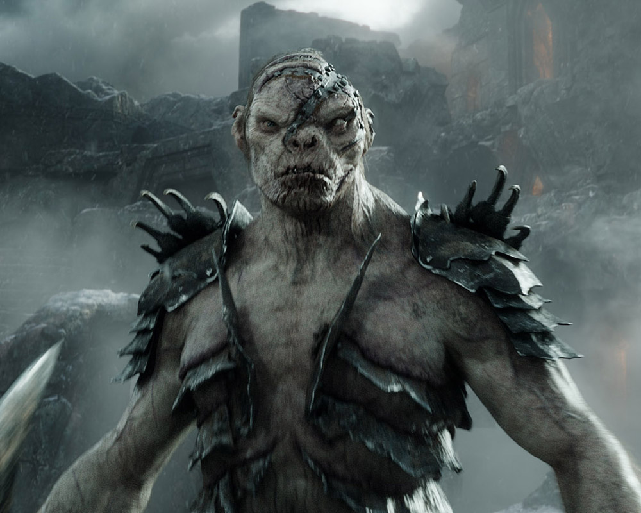

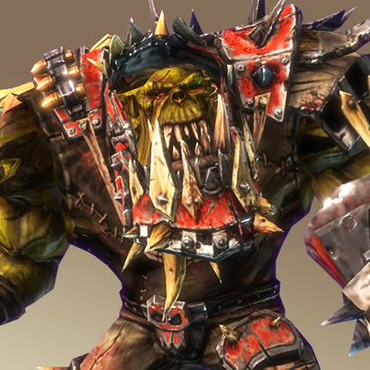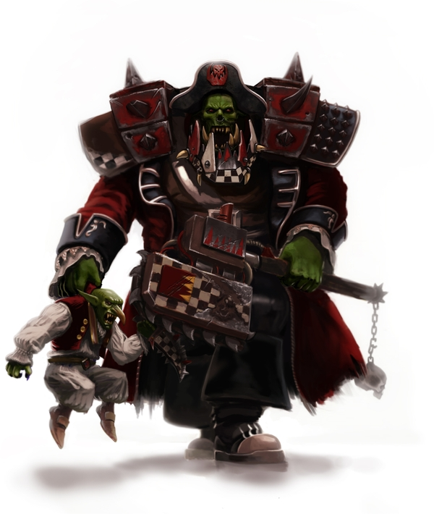

The orcs above are from Warhammer 40k and the Lord of the Rings universe. The idea is to combine the gritty realism of the Lord of the ring orcs with the modern steampunk feel of the 40k orcs.

## Similar Game

Defence Grid 2 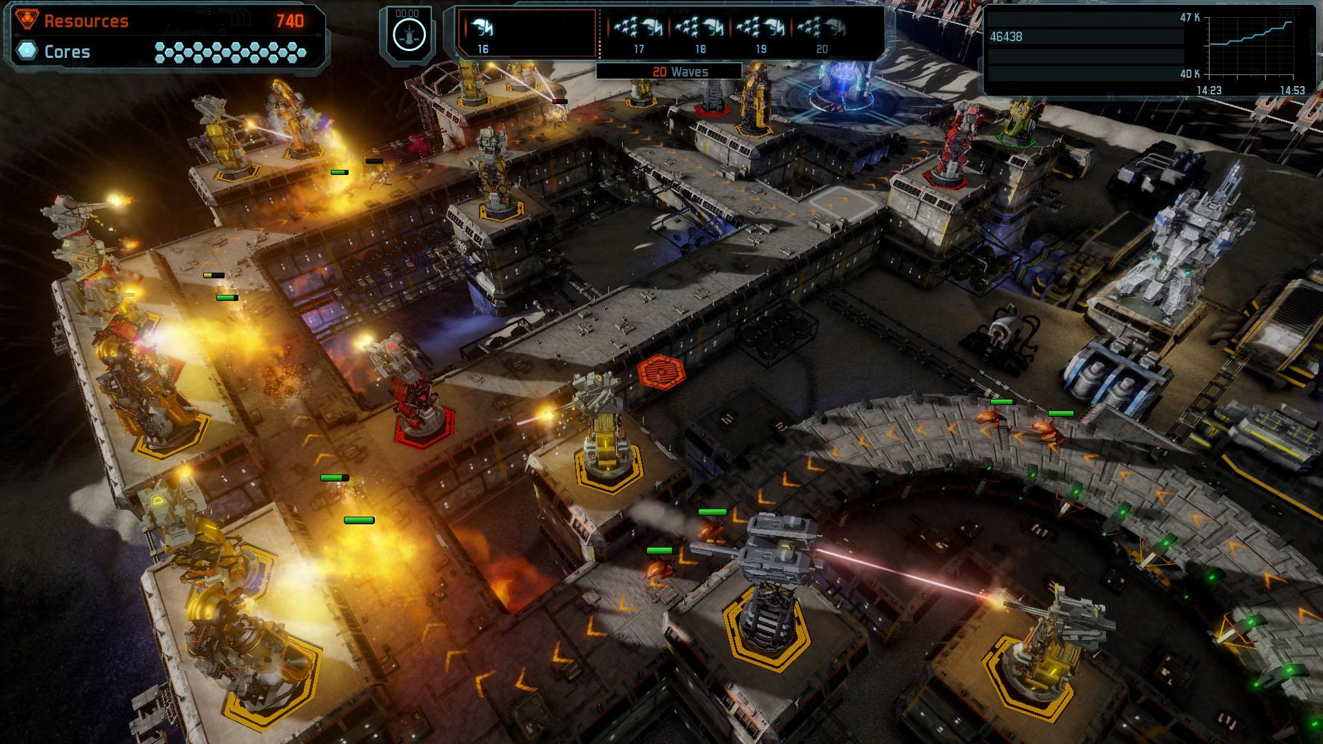

Game Link: http://store.steampowered.com/app/221540/

# Technical

## Target Hardware

Aiming for Medium to High spec PCs. The game will have a large variety of graphics options which means it should be customisable to a large number of PC configurations.

## Development Software

We would be developing this game in Unreal 4 as it is better suited at handling large amounts of characters on screen at once in an RTS style. The engine is more versatile compared to other engines and offers better optimisation as it doesn’t rely on garbage collection.

## In Game Controls

All controls in game will be rebindable, these are the default control schemes.

**Human Controls:**

* Mouse Movement - Move Camera,
* WASD - Move Camera,
* Mouse 1 - Select units/ Click UI Buttons,
* Mouse 2 - Give Orders
* Mouse 1 + Movement - Select units in an Area,
* E - Use unit’s special,
* Escape - Pause (In AI games only).

**Goblin Controls:**

* WASD - Movement,
* Mouse 1- Fire Weapon,
* E - Place Tower,
* Q - Tower Wheel,
* 1-3 - Select Tower,
* Escape - Pause (In AI games only).

7.4 Concept Drawings

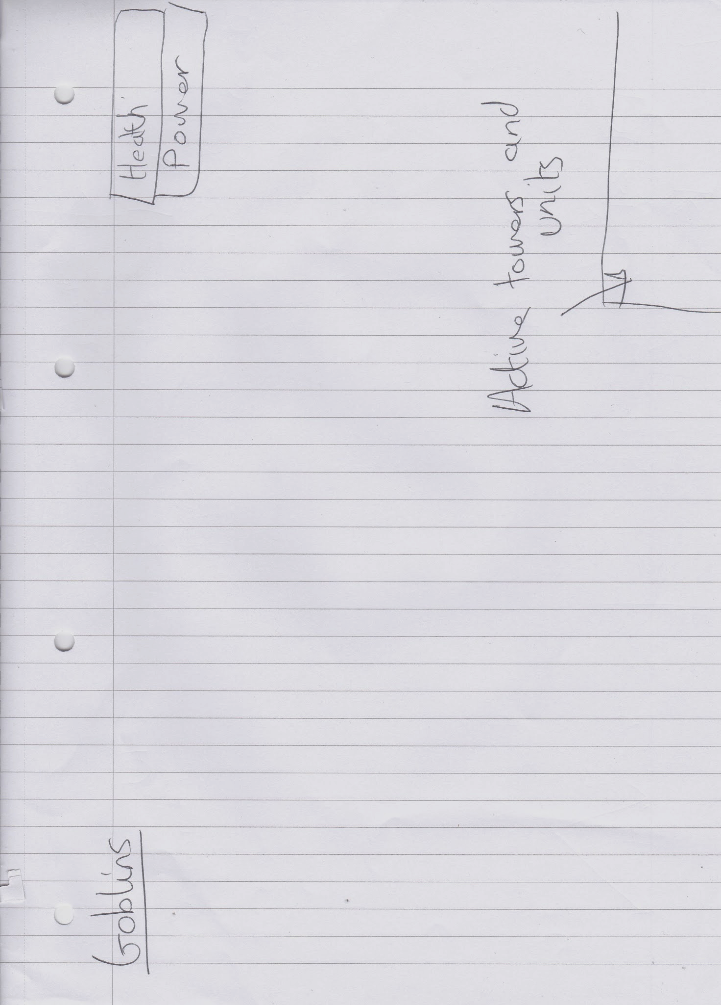

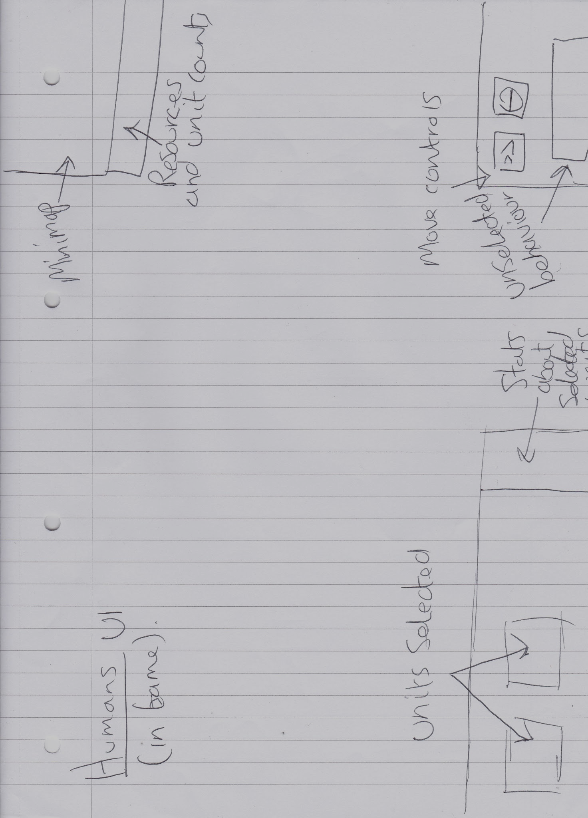

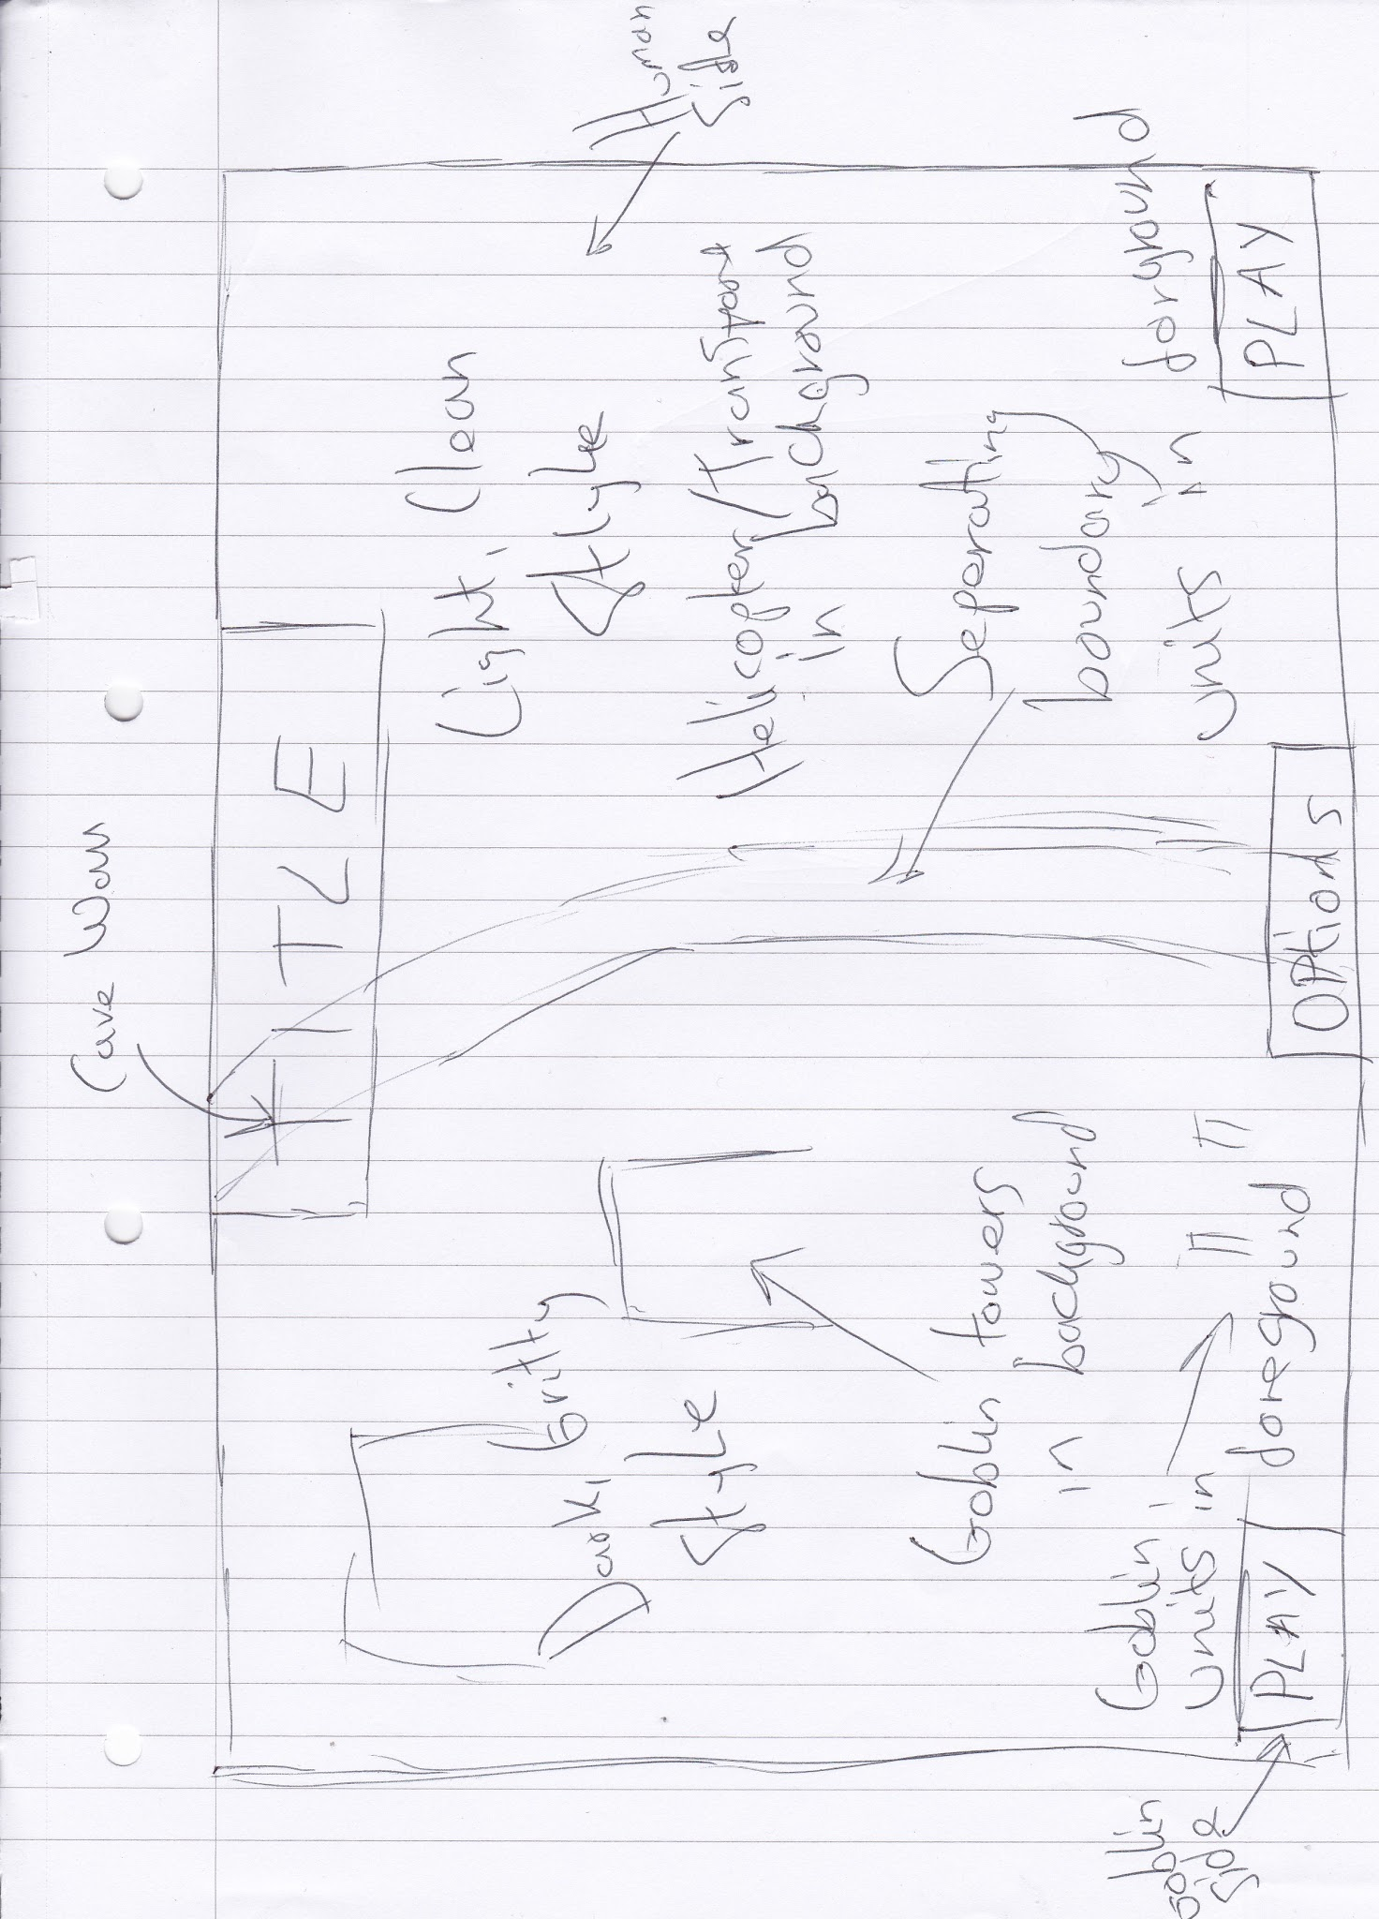

**Image references**

Goblins

<http://www.mangapolis.com/?m=201308>

<http://thepeeringeye.com/the-koltham-quests>

Humans

<http://www.hutui6.com/imperial-wallpapers.html>

<http://skvor.deviantart.com/art/Future-Soldier-concept-315885263>

Towers

<http://robhawkinshobby.blogspot.co.uk/2014_09_01_archive.html>

<http://serinur.deviantart.com/art/Siege-Tower-83813909>

Game worlds

<http://kotaku.com/5905231/18-things-about-dishonored-you-should-know>

<http://razor-games.com/wp-content/downloader/2016/07/Dark-Souls-3-2-980x551.jpg>

Orcs

<http://wallpaperswa.com/Art_Design/Digital_Art/warhammer_40k_kaptain_badrukk_ork_1477x1748_wallpaper_40142>

<http://www.dakkadakka.com/gallery/16745-.html?m=2>

<http://lotr.wikia.com/wiki/Bolg>

<http://www.giantbomb.com/forums/middle-earth-shadow-of-mordor-633129/name-that-uruk-1496099/>